Keyword: interaction design

What is Interaction Design

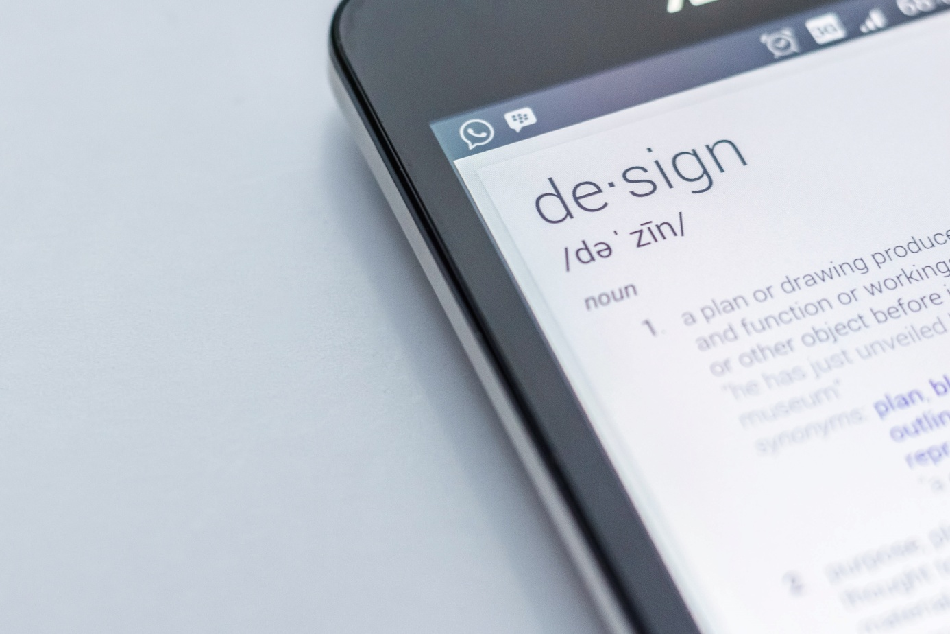

Modern devices and applications are getting more complex daily, and so does the users’ interaction with them. New technologies can sometimes be hard to use, and if people can’t understand them immediately, they tend to stop using them.

Users have come to expect an optimized, seamless user experience as a basic requirement across all devices (desktop, mobile, tablet). The most important step in creating a digital experience that not only attracts visitors, but also provides real value to them and the company begins with developing user experience (UX).

That’s why UX design is so important in modern business. If you create a product for the web (for example, a website or an app), you must make sure it’s easy to use.

User experience (UX) design can be defined as the process of creating products that provide meaningful and personally relevant experiences.

An important concept in UX design is the process by which users form experiences. When first encountering a product, a user forms a momentary impression—which evolves over time, typically as the product is used throughout a time period.

Most of today’s businesses are digital (ecommerce webshops, for example), or at least have a digital presence (website, blog etc.). So when talking about UX design most people refer to designing digital experiences, for example: a buying process in a webshop, or using an app.

I’ve mentioned that modern products have to be easy to use. This brings us to the term usability.

Usability is an attribute that assesses how easy user interfaces are to use. The word "usability" also refers to methods for improving ease-of-use during the design process.

The task of every good designer is to improve usability of the products he or she is working on.

But aside from usability, there’s also one important part of UX design, and that’s interaction design.

According to definition from Interactive Design Association (IxDA): Interaction Design (IxD) defines the structure and behavior of interactive systems. Interaction designers strive to create meaningful relationships between people and the products and services that they use, from computers to mobile devices to appliances and beyond. Our practices are evolving with the world.

Simplified, it can be said that interaction design is the design of interactions between users and products. Most often when people talk about interaction design, the products tend to be software products like apps or websites. The goal of interaction design is to create products that enable the user to achieve their objective(s) in the best way possible.

The field of interaction design can be divided into five pieces:
- Human/machine communication is the translation of conversations between the device and user.
- Action/reaction looks at how interactions happen and unfold.
- State ensures that users know what is happening and why in terms of the application.
- Workflow ensures that users know who to use a tool or application and what happens next.
- Malfunction takes into account mistakes that are bound to happen.

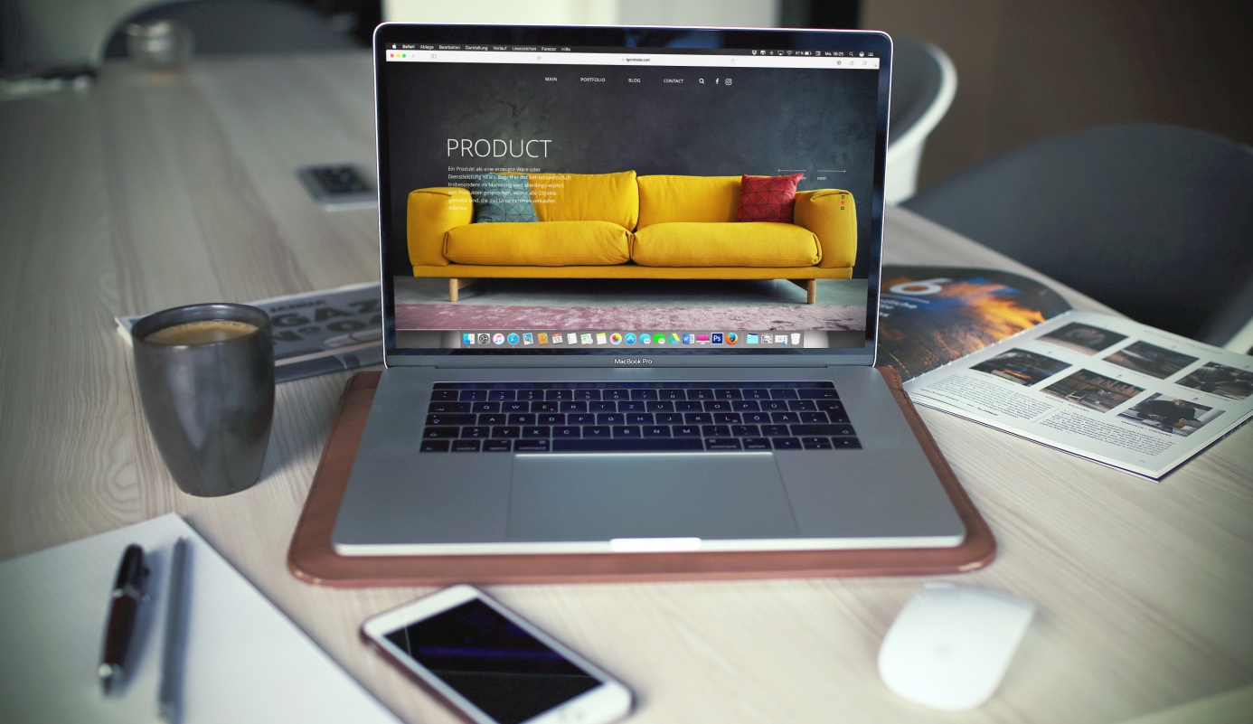

Interaction design concepts (h2)

There are three main concepts in interaction design.

1) Goal driven design (h3)

Goal-driven design focuses first and foremost on satisfying specific needs and desires of the end-user, as opposed to older methods of design, which focused on what capabilities were available on the technology side of things.

2) Usability (h3)

Interfaces need to be designed in such a way that they make the state of the underlying system easy to use.

In the book Human Computer Interaction by authors Alan Dix, Janet E. Finlay, Gregory D. Abowd, Russell Beale, usability is broken down into three principles:

- Learnability: how easily can a new user learn to navigate the interface?
- Flexibility: how many ways can a user interact with the system?
- Robustness: how well are we supporting users when they face errors?

3) The five dimensions (h3)

The 5 dimensions of interaction design is a useful model to understand what interaction design involves. Gillian Crampton Smith, an interaction design academic, first introduced the concept of four dimensions of an interaction design language, to which Kevin Silver, senior interaction designer at IDEXX Laboratories, added the fifth.

- 1D: words should be simple to understand, and written in such a way that they communicate information easily to the end user.
- 2D: visual representations are all graphics or images, essentially everything that is not text. They should be used in moderation.
- 3D: physical objects or space refers to the physical hardware, whether it’s a mouse and keyboard, or a mobile device a user interacts with.
- 4D: time is the length that the user spends interacting with the first three dimensions. It includes the ways in which the user might measure progress, as well as sound and animation.
- 5D: behavior was added by Kevin Silver in his article, What Puts the Design in Interaction Design. It is the emotions and reactions that the user has when interacting with the system.

Conclusion (h2)

Designing products or services is no longer only about the visual design. It’s about creating a positive user experience, and enabling users smooth, pain-free interactions.

It’s important to apply the core interaction design principles in modern design projects, since users have come to expect products that provide them with that kind of experience, and companies are building success on providing excellent experiences to their consumers.

If you need help with applying interaction design to your projects, contact us today and we’ll be glad to help you out.

